**October-December, 2020**

Luisa Baars and Jazmin Ruiz delivered books

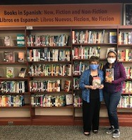

* Essay contest announced
* Hispanic Heritage Month book drive
* Photo of book delivery and photo of Thanksgiving Dinner
* Quote
* Voter registration drive
* Thanksgiving Day dinner
* Focus on diversity, equity, and inclusion
* New member inducted
* Christmas dinner and photos
* What your club can do
* Dr. Evelyn Arana and team
* Vaccinations
* Board of Directors
* Object of Rotary
* Quote

In this issue

**The cooks, left to right: Aida Veras, Charol Ríos, Luisa Baars, Norma Heyn (front) and Jazmin Ruiz, back**

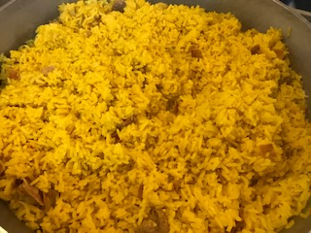

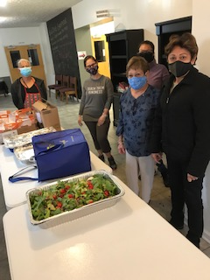

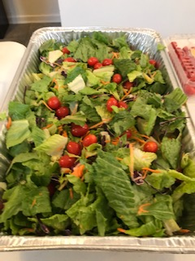

**Essay contest announced**

Miriam Vázquez, chair of the Literacy Committee, announced the upcoming essay contest on the topic of Social Unrest. The contest is open to middle and high school students attending schools in the Rochester City School District.

Students need to include in their essays an analysis of the current social unrest experienced in our country and how Dr. Eugenio María de Hostos, a medical doctor, educator, philosopher, and advocate for the independence of Puerto Rico and Cuba would react to it. He was a Puerto Rican who studied literature and medicine in Spain in the 19th century.

Essays will be evaluated by club members, and prizes of $100, $50.00, and $25 will be awarded to the winners of first, second, and third places, respectively.

**Hispanic Heritage Month book drive**

The RLRC conducted a book drive from October 7 to November 7. Books were in Spanish or English written by Latino authors. Books were delivered to the Lincoln Public Library located on Joseph Avenue in Rochester.

Club members donated 50 books to the library. It was observed that the library has a rather large Spanish section, including bilingual dictionaries and several books written by Latino authors. This library is located in an area where many Latinos live.

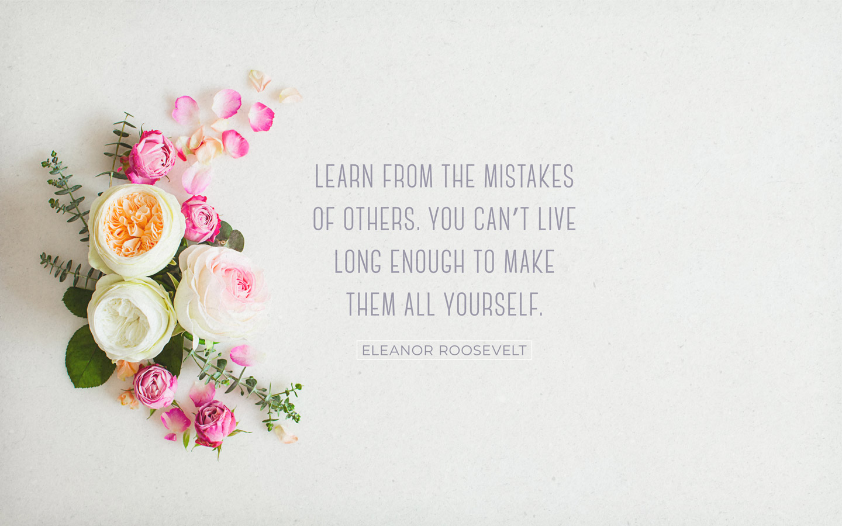



Take action, visit: www.latinorotary.com Facebook: Rochester Latino Rotary Club

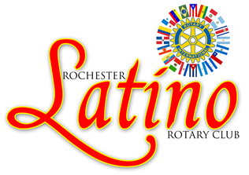

**Spring is in the air**

* Rotary Convention

# Rochester Latino ROTARY CLUB La Rotariana

**ACTION:** wwwlatinorotary.com

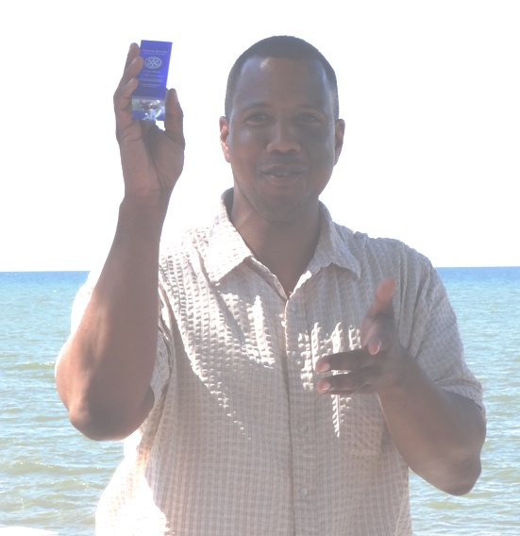

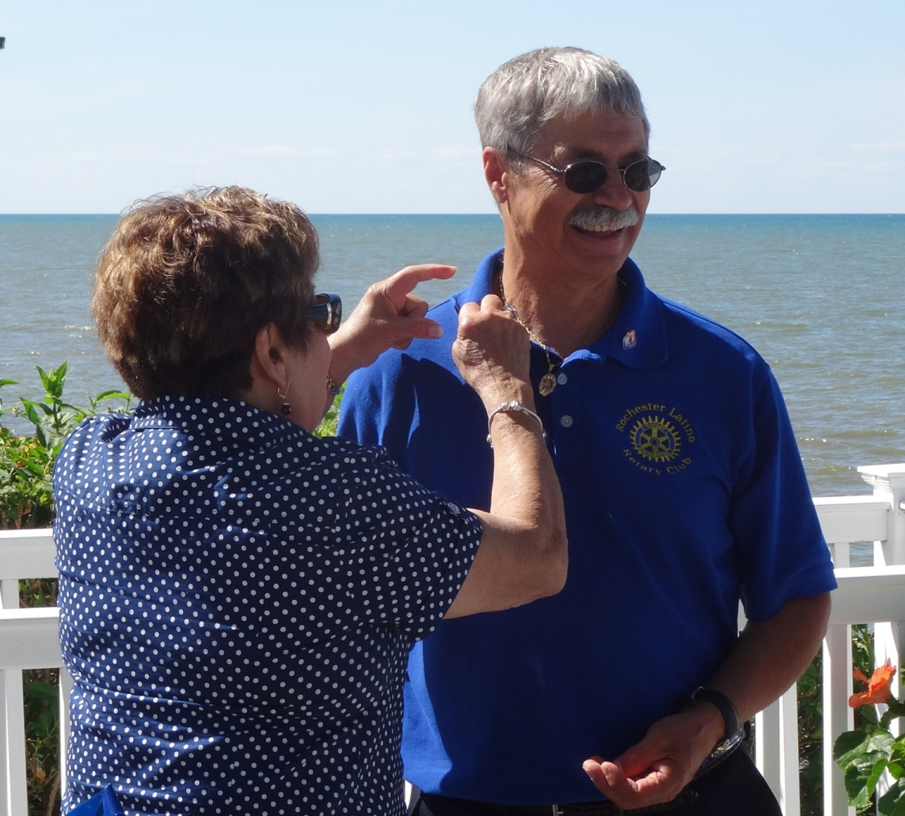

**2016**

C

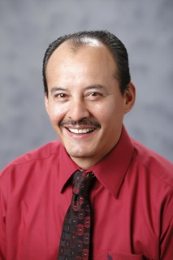

experience in Public Health: ​​HIV/AIDS, Federal Health Law (Obama Care), research with the Universities of Kansas-KUMC, Hackensack UHMC, and URMC. He studied at the Autonomous University of Chihuahua, Mexico - Faculty of Chemistry in the area of ​​Food Engineering.

He is married to Dora Alicia Ponce; they have 2 children and an adopted daughter, and a granddaughter. He is very active at the San Patricio Church and several local, state, and national organizations. He has received numerous recog -nitions for his work including Secretary of Foreign Relations with the Government of Mexico OHTLY 2015 Recognition.

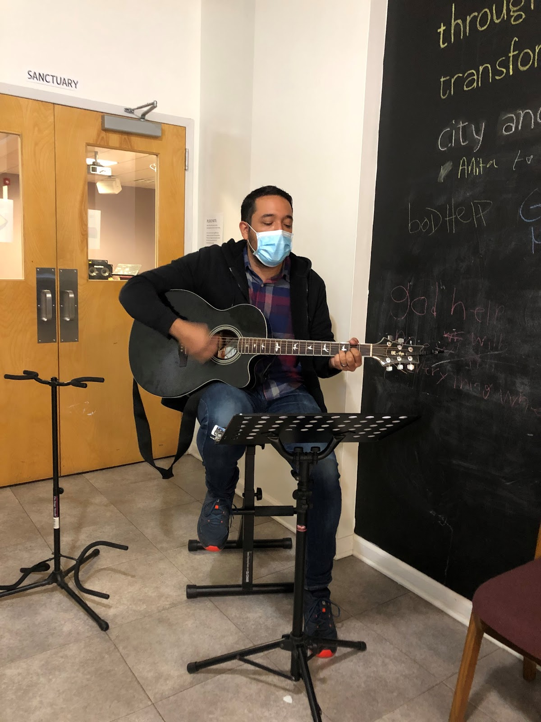

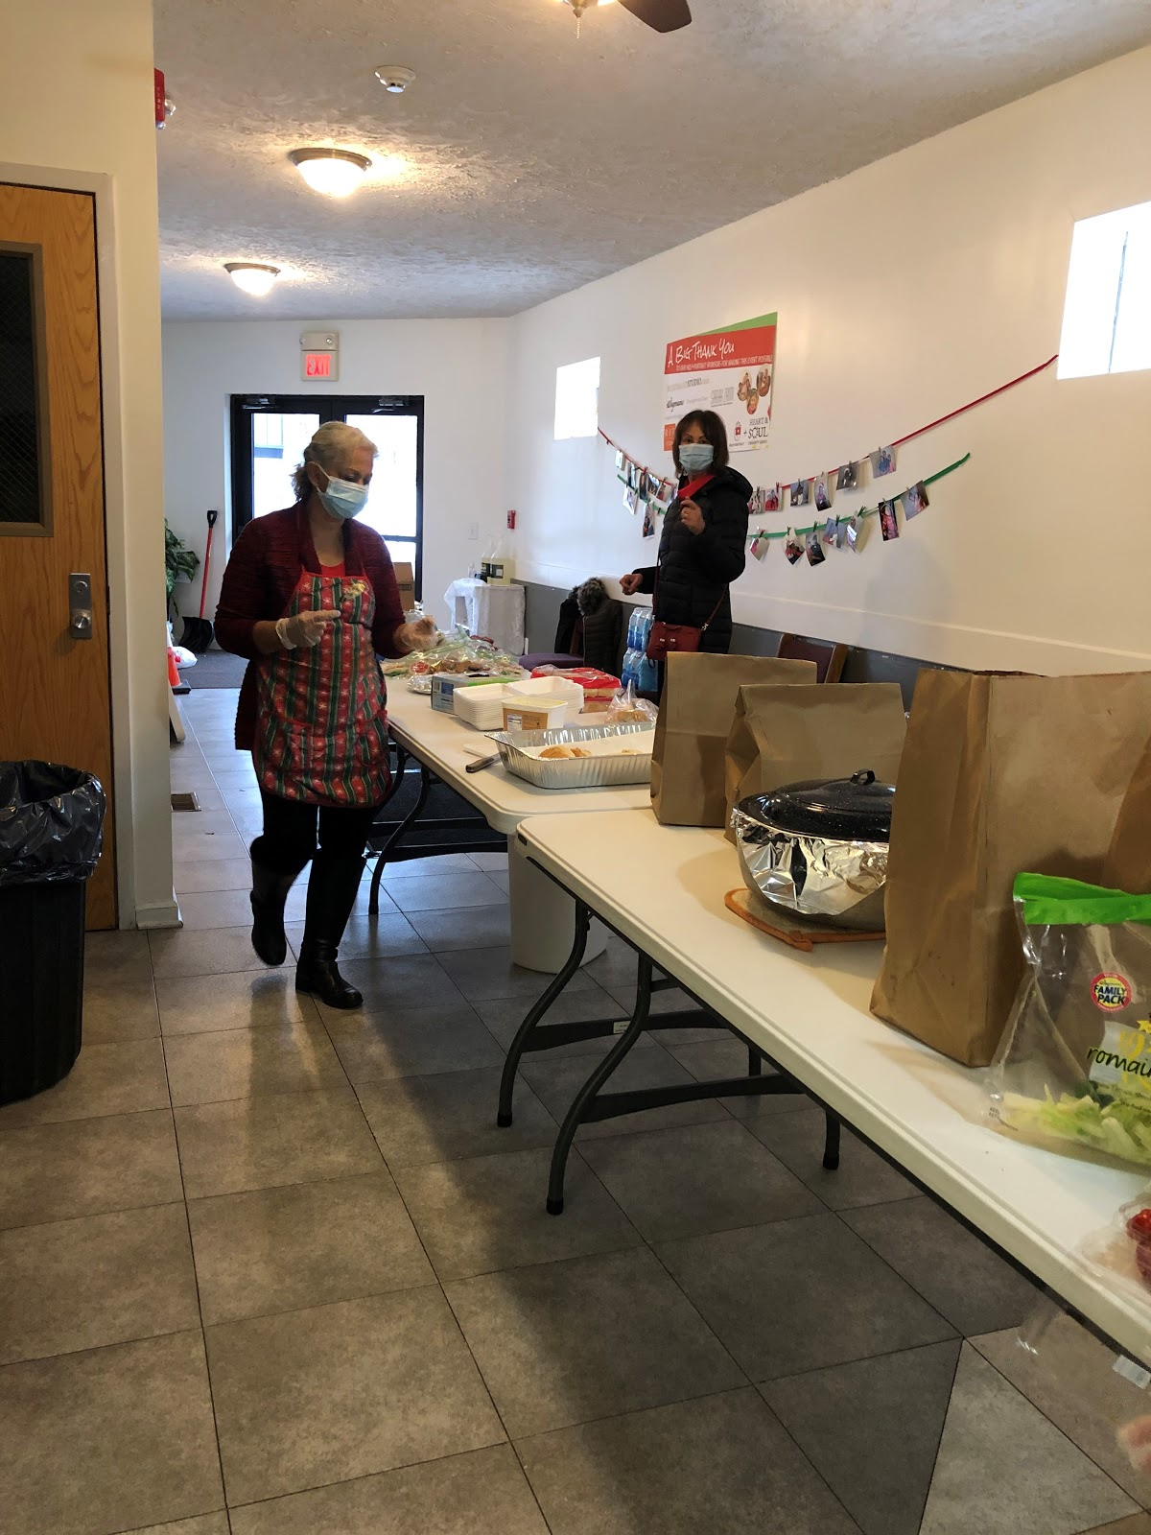

**Christmas dinner**

The holidays are a time for sharing, helping and giving, and the RLRC is always there to lend a hand. During the festivities of Christmas, many club members and volunteers gave their time for cooking, packing, and serving a delicious meal. This event was held on December 20th in the afternoon at Heart and Soul Church where approximately 70 dinners were served. All safety precautions were observed including masking and no meal eaten at the site. The menu consisted of green salad, rice, roast chicken, pasta, potato salad, mac salad and bread. Thanks to Pastor Colón for making our time very enjoyable with his beautiful music.

**Arturo Ponce**, originally from Mexico is the newest member of the club. Currently, he is a bilingual community liaison at the University of Rochester Medical Center Community Outreach, Engagement and Disparities. He has extensive

**Voter registration drive**

The RLRC conducted a voter registration drive on October 3rd at the Father Laurence Advocacy Center on Clinton Avenue, Rochester. Several members provided information regarding advanced voting dates and sites, and registered several individuals.

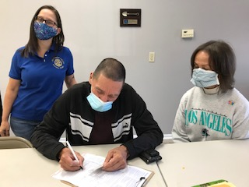

Charol Ríos and Elisa DeJesús observe while a new voter completes registration form

**Thanksgiving Day dinner**

Following the RLRC focus on helping families in need during the festivity of Thanksgiving Day, several club members cooked, packed, and served dinner at the Heart and Soul Church on November 24th. Following restrictions due to the COVID-19 pandemic, instead of serving dinner at the church, dinner was pre-package and people just took it home. About 80 dinners were pre-package and the rest of the food was donated to the House of Mercy.

Dinner consisted of roasted chicken, green salad, macaroni salad, several types of rice and dessert. There was Panamanian rice with coconut, Puerto Rican rice with pigeon peas, and yellow Mexican rice.

**Focus on diversity, equity, and inclusion**

A top priority for Rotary is growing and diversifying our membership to make sure we reflect the communities we serve and are inclusive of all cultures, experiences, and identities.

RI is creating an organization that is more open and inclusive, fair to all, builds goodwill, and benefits our communities. **Cont. p3**

**New member inducted**

**TAKE ACTION, VISIT:** wwwlatinorotary.com



**La Rotariana** 2  **October-December, 2020**

**La Rotariana 3 October - December, 2020**

**Dr. Evelyn Arana and team were guest speakers**

Arturo Ponce introduced Dr. Arana who is a Research Assistant Professor in the Public Health Sciences Department at The University of Rochester School of Medicine & Dentistry. Dr. Arana is a social and behavioral scientist whose research includes promoting cancer prevention and control among underserved and understudied populations incorporating principles of community-based participatory approach in the U.S., Mexico, and Guatemala. Currently, she is working on the imple- mentation of a text messaging randomized smoking cessation clinical trial for Latinos in the U.S.

She asked club members what experience they had with cancer. Several types of cancer were mentioned: brain, stomach, breast, leukemia, sarcoma, and thyroid. Some of the outcomes: metastasis, death, amputation of legs, living with cancer. Some of the barriers confronted by Latinos regarding dealing with cancer: fear of diagnose, language, lack of insurance, not having a primary care physician, lack of health care professionals culturally competent, don’t like to take medicines, lack of trust in the system, lack of access to resources, lack of participation in clinical trials, Latinos not treated the same as white Americans, lack of knowledge, and access to preventive measures.

Possible causes of cancer: smoking, use of illegal drugs such as marijuana, diet, lack of exercise, overweight, genetic factors, and environmental factors.

Possible solutions: education, training of health care professionals on cultural issues, having more Spanish speaking providers, use of media (radio, TV, social media) to provide education on prevention, resources, etc., advocate for access, insure education is provided on a continual basis, provide free screenings.

How to provide education, resources, and access: partner with Latino organizations, use churches as vehicles for information, provide information at La Marketa, and make sure **Cont. p 4**

To help us achieve this goal, the RI Board of Directors passed a diversity, equity, and inclusion (DEI) statement: *“As a global network that strives to build a world where people unite and take action to create lasting change, Rotary values diversity and celebrates the contributions of people of all backgrounds, regardless of their age, ethnicity, race, color, abilities, religion, socioeconomic status, culture, sex, sexual orientation, and gender identity.”* Rotary will cultivate a diverse, equitable, and inclusive culture in which people from underrepresented groups have greater opportunities to participate as members and leaders.

### What your club can do:

* Talk about diversity with your club members and create a member diversity and inclusion action plan using the [Diversifying Your Club](https://my-cms.rotary.org/en/document/diversifying-your-club-member-diversity-assessment) assessment.
* Invite local diversity, equity, and inclusion experts to speak at your club’s next gathering.
* Connect with local organizations that are supporting diversity, equity, and inclusion efforts and work with them on projects or events.
* Encourage and support people from under-represented groups to take on leadership positions in your club and district.
* Encourage club members to take the [Building a Diverse Club](https://my-cms.rotary.org/en/learn?deep-link=https%3A//learn.rotary.org/members%3Fr%3Dsite/sso%26sso_type%3Dsaml%26id_course%3D42) course in the Learning Center to learn more about diversity, equity, and inclusion.
* Create a community advisory board and invite diverse members from the community and from your club to take part. You'll learn what's important to the community and discover ways to work together to take action.

**Note:** Information on diversity accompanies this issue as a separate document.

What is my responsibility as a Rotarian to insure the club fosters diversity, equity, and inclusion not only among the members but also in its projects and activities? This is a topic that should be study and discussed as we assess how the club is in sync with the diversity statement issued by RI Board of Directors.

**Look for the club on Facebook at Rochester Latino Rotary Club**

**Focus on diversity, Continued**

The Object of Rotary is to encourage and foster the ideal of service as a basis of worthy enterprise and, in particular, to encourage and foster:

1. The development of acquaintance as an opportunity for service;
2. High ethical standards in business and professions; the recognition of the worthiness of all

useful occupations; and the dignifying of each Rotarian’s occupation as an opportunity to serve society;

1. The application of the ideal of service in each Rotarian’s personal, business, and community life;
2. The advancement of international understanding, goodwill, and peace through a world fellowship of

business and professional persons united in the ideal of service.

**La Rotariana** 4 **October-December, 2020**

**Dr. Arana. Cont.**

gatekeepers in the community are contacted (that is, ministers, barbers, small business owners in the neighborhood, etc.).

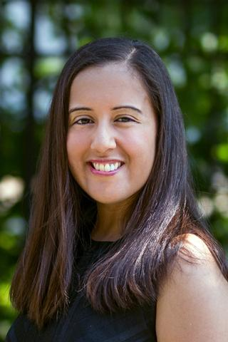

**Dr. Evelyn Arana**

**THE FOUR WAY TEST**

Of the things we think, say, or do

1. Is it the TRUTH?

2. Is it FAIR to all concerned?

3. Will it build GOODWILL and BETTER FRIENDSHIPS?

4. Will it be BENEFICIAL to all concerned?

**Vaccinations** The COVID-19 pandemic has created health challenges that go beyond the disease itself. In May 2020, the World Health Organization reported that, worldwide, 80 million children under age one [were not receiving routine vaccinations](https://www.who.int/news-room/detail/22-05-2020-at-least-80-million-children-under-one-at-risk-of-diseases-such-as-diphtheria-measles-and-polio-as-covid-19-disrupts-routine-vaccination-efforts-warn-gavi-who-and-unicef) for a variety of diseases. Pausing vaccinations — which involve close contact between vaccinators, infants, and their families — was necessary in the face of the pandemic. But as UNICEF Executive Director Henrietta Fore warns, “We cannot exchange one deadly outbreak for another.”

Amid these challenges, Rotary’s contributions toward polio eradication are more important than ever. In January 2020, the Bill & Melinda Gates Foundation and Rotary [renewed their long-standing partnership](https://www.rotary.org/en/rotary-and-bill-melinda-gates-foundation-extending-fundraising-partnership-eradicate-polio), committing to raise an additional $450 million for polio eradication over the next three years. Rotary is committed to raising $50 million each year, with every dollar to be matched with two additional dollars from the Gates Foundation. “While response to the COVID-19 pandemic is an urgent global health priority, we cannot let our progress against polio backslide,” says Michael K. McGovern, chair of Rotary’s International Polio Plus Committee and a member of the [Global Polio Eradication Initiative](http://polioeradication.org/) (GPEI) Polio Oversight Board.

**Club Board of Directors**

President – Elisa DeJesús

Immediate Past President – Migdalia Concepción

President Elect – Aida Veras

Treasurer – Idalia Chang, Miriam Vázquez

Secretaries – Jazmin Ruiz

Luisa Baars

Club Service Co-Chairs - Aida Veras

Charol Ríos-Davis

International Service Chair – Luisa Baars

Membership Chair – Orlando Rivera

Foundation Chair – Julio Vázquez

Literacy Co-Chairs –Miriam Vázquez

Julio Vázquez

Club Webmaster – Jazmin Ruiz, Orlando Rivera

Bulletin Co-Editors - Luisa Baars – Norma Heyn

Program Chair – ElisaDeJesús

Fund Raising – Jazmin Ruiz

Sergeant-At-Arms - To rotate among directors

**The Object of Rotary**

**2021**

**“If the plan does not work, change the plan, but never the goal.”**

* **Author unknown**